The 2023 Governor’s Conference Welcomes You to Milwaukee!

Enjoy these downtown experiences while you are with us for the
2023 Governor’s Conference. There are many great restaurants within walking distance of the Hyatt.

Check out Visit Milwaukee - Things to do - Your guide to Milwaukee for additional dining ideas!
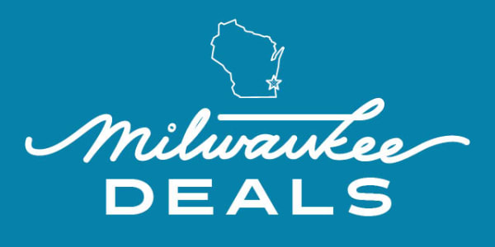
MILWAUKEE DEALS PASS
Your Milwaukee experience starts here. With the Milwaukee Deals Pass, you can do more for less. Save on your next visit to downtown restaurants, breweries, museums, theaters, local boutiques, tours, activities, and more. Start exploring and saving today!
FREE PASS – No apps to download

Visit Milwaukee - Milwaukee Deals

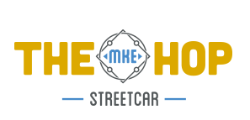

THE HOP IS FREE TO RIDE!
No tickets or vouchers needed! Just hop on and hop off to connect with jobs, entertainment, dining and more!
The Hop MKE | Milwaukee Streetcar
3rd St. Market Hall - The Best Food in Milwaukee (3rdstmarkethall.com)

Local food
From treasured Wisconsin classics to ethnic fare, our food vendors bring the best of the best representing Milwaukee's rich and diverse heritage. Each and every vendor is locally owned and operated and uses the finest and freshest ingredients for true scratch cooking.
View Vendors
3rd st. bar
Explore a carefully curated menu featuring popular and fine wines, spirits, and beers from right here in Milwaukee to across the globe. Get comfortable and stay a while while you quickly and easily order from your favorite vendors.
See the Menu
Games
Shuffleboard, bags, Topgolf Swing Suite, Nintendo, and much more - there’s a fun fit for everyone. Enjoy each one of these spaces in our comfortable, casual, and high-energy atmosphere.

