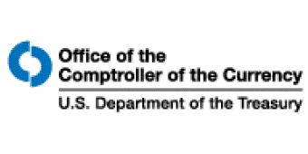
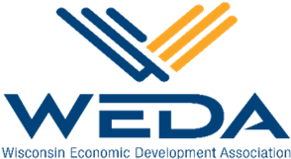
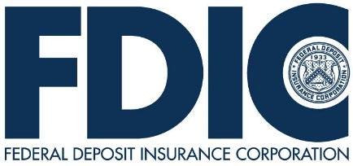
CRA Banker Roundtable
Hybrid Event

2023 WEDA Best Practices Conference
Jefferson Street Inn in the CHAR Grillhouse
201 Jefferson St, Wausau

September 27, 2023, from 10:00 to 12:30 PM Central Time

Agenda
10:00 Welcoming Remarks & Introductions

Carol Maria, Community Affairs Specialist, FDIC
Steve Kuehl, Community Affairs Officer, OCC

10:15 WEDA CRA Network Updates

Mary Perry, President and Chief Executive, WEDA

10:30 Community Development Opportunities

- Sam Wessel, AICP, Northwestern Regional Planning Commission
- Jenny Radcliff, Jenny Kuderer-Radcliffe, CEcD, Economic Development Manager, Dairyland Power Cooperative
- Keely Campbell, Manager Development, Ayres

11:30 Best Practice Discussion

12:00 Networking Lunch (remote connection ends)

12:30 Adjourn

