Tax Increment Financing 201
September 27, 2023
9:15 a.m. – 1:15 p.m.

Jefferson St. Inn, Lincoln Ballroom
Wausau

AGENDA
9:15 AM | Welcome  Kathleen Heady, CEcD, Manager, Wisconsin Economic Development Academy, Wisconsin Economic Development Association
9:20 AM | Tax Increment Financing Basics  Ehlers
10:00 AM | Wausau Project Example, First Exercise, Proforma Review and Negotiation  Randy Fifrick, Ehlers
10:45 AM | Break
11:00 AM | Best Practices, Project Examples and Introduction to Exercise 2  All Instructors
11:45 AM | Grab Box Lunch and Work on Exercise 2
12:30 PM | End of TIF Life, TIF Closure, Upcoming TIF Changes  Ehlers
1:05 PM | Final Questions and Wrap up

Instructors

Philip Cosson, CIPMA, Senior Municipal Advisor/Board Chair Ehlers
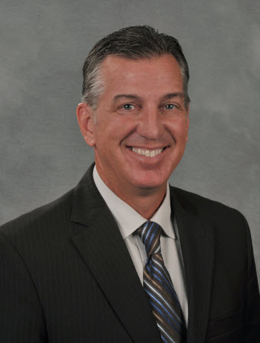
Phil is a Senior Municipal Advisor who’s been in the Ehlers’ Wisconsin office since 1996 guiding local governments and public agencies in creating financial solutions that support the growth and maintenance of vibrant and sustainable communities. He also serves as the Chair of Ehlers Companies Board of Directors. Prior to joining Ehlers, he worked with the Southeastern Wisconsin Regional Planning Commission and the City of Ocala, Florida for over eight years. Phil is passionate about building long-lasting relationships with clients and collaborating to create meaningful change.

Greg Johnson, CIPMA, Senior Municipal Advisor, Ehlers
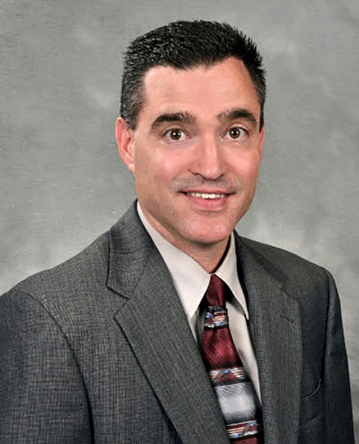
Greg is a Senior Municipal Advisor with Ehlers’ Wisconsin municipal team. He guides local governments and public agencies in design and implementation of financial solutions that empower communities to advance their critical missions. Prior to joining Ehlers in 2005, Greg worked in municipal government as an administrator in Kansas, Illinois and Wisconsin. Clients depend on Greg for his ability to comprehensively analyze their financial landscapes and construct innovative debt issuance and economic development programs.

Company Information:
A pioneer in municipal advisory services since 1955, Ehlers helps clients build strong, vibrant and sustainable communities by delivering independent, integrated advice across all areas of public finance. We work with more than 1,500 local governments, schools, and public agencies across five states, placing our clients’ needs and best interests at the center of everything we do.

Instructors

Randy Fifrick, Economic Development Manager
City of Wausau, Community Development Department

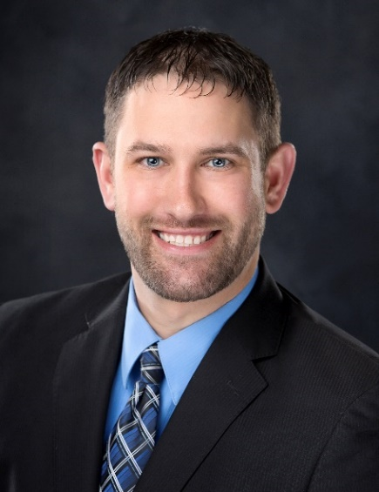
Randy Fifrick is the Economic Development Director for the City of Wausau and is responsible for leading the City’s efforts in cultivating businesses, attracting residents, and growing the City’s tax base. Serving in this role since 2021, Randy is committed to positive change, finding innovative solutions to complex problems, and attracting targeted, strategic growth to the City.

Before joining the City of Wausau, Randy spent 12 years as the Village of Kronenwetter’s Community Development Director, as the Village’s very first Development Director. Prior to moving to Marathon County, Randy studied Land Use Planning and GIS/Spatial Analyst at UW-Stevens Point and worked for the Ravalli County Planning Department in Western Montana.

Randy is actively engaged in his community, having served three terms on the Marathon County Board and on the Marathon County United Way Emerging Leaders Board of Directors. In 2016, Randy was honored as one of the areas’ 20 Under Forty, an award recognizing his leadership, achievement, and commitment to the community.

Melissa Hunt, CEcD, EDFP
Melissa has almost twenty years of experience assisting communities with developing and implementing effective planning, community, and economic development strategies. She works cooperatively with community leaders, regional and state organizations, business owners and key stakeholders to successfully lead and support opportunities for growth and development. Melissa has worked in local government, at the county level, for the Wisconsin Economic Development Corporation (WEDC) and as a manager and shareholder at Vierbicher. Melissa is active in many organizations including the Wisconsin Economic Development Association (WEDA), the Vice Chair of the Board, and the Wisconsin Downtown Action Council (WDAC) Board.

