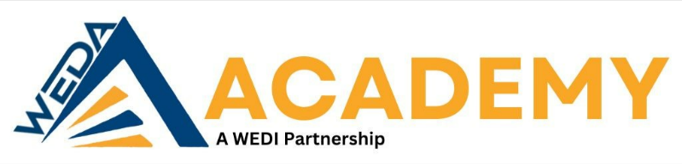
Executing Neighborhood Revitalization
Featuring Jeff Siegler of Revitalize, or Die https://revitalizeordie.com
May 22, 2024
8:30 – 11:30am
River City Church
613 N 5th St., Wausau, WI 54403

Organization Contact Person and Contact Information | Cyndi Schmear, Wisconsin Economic Development Association Operational Director; cschmear@weda.org
General Organization Information (i.e. website address, short description of organization, etc.) | For nearly 50 years, the Wisconsin Economic Development Association (WEDA) has represented the economic development interests of both the private and public sectors through advocacy, education, and leadership on statewide initiatives. Driven by the needs of our members, we are committed to providing the resources and tools to promote economic prosperity in Wisconsin. WEDA is proud of our history, our growing list of accomplishments, and our past, current, and future efforts that make it possible for economic development professionals and organizations to be successful. The WEDA Academy aims to advance economic development through education and offers multiple training opportunities on the leading economic and community development issues of the day. The seminars are taught by recognized industry experts and provide continuing education  credits.
Academy Course Model | In – Person Comprehensive Program
Name of Academy Course: | Executing Neighborhood Revitalization with Jeff Siegler, founder of Revitalize, or Die, a civic pride consulting firm, and co-founder Proud Places.
Technology Required (LCD projector, flip chart, etc.) | LCD projector, screen, laptop
Training Objectives
 |  | The presentation of action steps to help take community input, discussions, planning, and concepts to actual progress in execution will give attendees tactics and tools to begin implementing quickly. These tools Jeff has successfully used have turned aspirations into reality due to his attention to the practicalities of implementation and his methods which are focused on tangible results.
Description of Session or Course | Jeff has assisted hundreds of communities with their revitalization, economic sustainability, and community development over the course of his career. He will present solutions to discover your community’s potential and overcome civic stagnation. Utilizing a background in urban planning, downtown district management, revitalization, real estate, economics and organizational development. With his diverse background and expertise Jeff will share a unique vantage point for addressing community concerns. Jeff Siegler website: https://revitalizeordie.com/about

Training Deliverables | Through this course attendees will gain:  - Practical, actionable steps to move forward from planning to execution.  - An overview of Jeff’s Downtown Playbook  - Ability to identify and focus on immediate, visible neighborhood improvements.
Instructor Jeff Siegler | Jeff Siegler is the driving force behind Revitalize or Die, a platform dedicated to helping individuals and organizations thrive in the face of change and adversity. With a background in coaching, consulting, and entrepreneurship, Siegler brings a wealth of experience to his work. Through his books and resources, he shares actionable strategies and insights for personal and professional growth, emphasizing the importance of resilience, adaptability, and innovation in today's rapidly evolving world. Siegler's approach is rooted in practicality and optimism, empowering his audience to embrace challenges as opportunities for transformation and renewal. His platform serves as a beacon of inspiration and guidance for anyone seeking to revitalize their lives and achieve lasting success.
Location | Jeff Siegler, Pittsburgh PA

Event Registration: https://weda.member365.com/public/event/details/3a4fed42d5e65f9ad6f76ab5bb4d2d785ff0a445/1

Bio: https://weda.org/wp-content/uploads/2024/04/May-22-Jeff-Siegler-Academy-supporting-CE-doc.docx

